SmartCourse - AI Powered Course Recommendation System
Software Requirements Specification

Version 1.0



Group Id: F25PROJECTEC4D8
Supervisor Name: Muhammad Bilal (bilal.saleem@vu.edu.pk)

Revision History
Date (dd/mm/yyyy) | Version | Description | Author
05-Nov-2025 | 0.6 |  | BC240419615
  Set up SRS structure, drafted project scope, identified actors and outlined initial functional requirements.
12-Nov-2025 | 0.7 | Expanded and refined functional & non-functional requirements, added use cases and documented key usage scenarios. | BC240419615
19-Nov-2025 | 0.9 | Added detailed recommendation workflow (TF-IDF/neural), REST API design, data pipeline steps and evaluation metrics. | BC240419615
30-Nov-2025 | 1.0 | Completed full document review: improved formatting, unified terminology, added consistency fixes and prepared final SRS version. | BC240419615

Table of Contents

- Scope (of the project)
- Functional Requirements Non Functional requirements
- Use Case Diagram
- Usage Scenarios
- Adopted Methodology
- Work Plan (Use MS Project to create Schedule/Work Plan)

SRS Document

Scope of Project:

SmartCourse helps university learners explore a catalog of more than 8,500 courses by translating natural language preferences into ranked recommendations. The Fall 2025 scope focuses on delivering a polished multi-page interface, a dependable Flask backend, and supporting scripts so the team can capture preferences, compare TF-IDF and neural perspectives, and track how learners interact with the system.
Out of scope: payment processing, Single Sign-On with university portals, and deep LMS integration. These can be considered in future releases once the recommendation workflow is stable.
Within scope: preference capture UI and REST API, TF-IDF/neural recommendation engines, SearchSession and saved-course persistence, data cleaning scripts, and evaluation tooling.

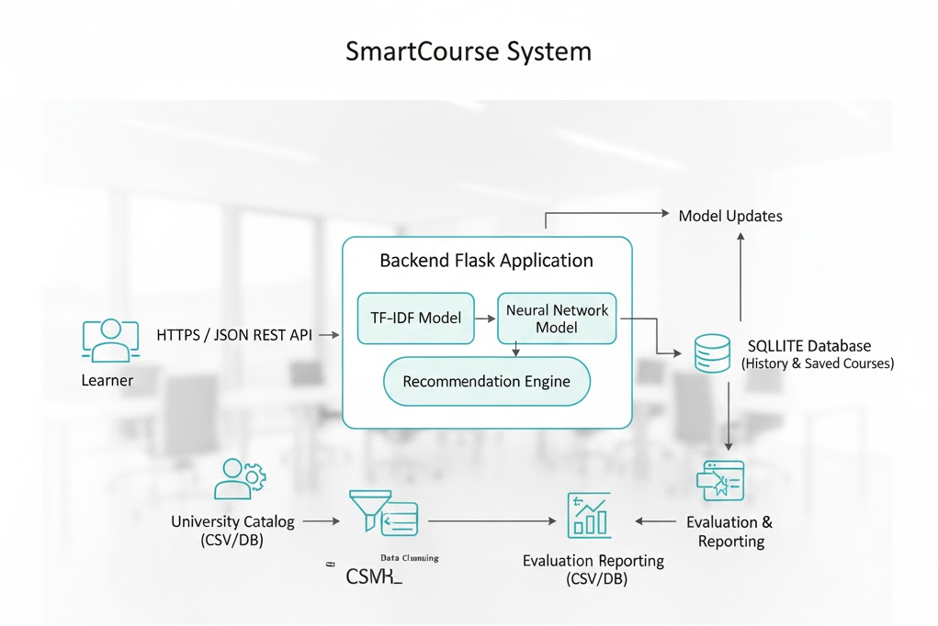

Functional and non Functional Requirements:

Functional Requirements:
FR-1 Preference capture: accept free-text input via the UI and /api/recommend endpoint and reject empty submissions.
FR-2 Model selection: allow TF-IDF, neural, or hybrid scoring with adjustable top-N results per query.
FR-3 Recommendation response: return course title, department, description, difficulty, rating, and relevance score for each model.
FR-4 Session history: store each recommendation request in SQLite so learners can revisit and compare past searches.
FR-5 Saved courses: enable bookmarking and removal of recommendations without deleting the associated session.
FR-6 REST APIs: expose recommendation, history, and save endpoints with JSON payloads and clear error handling.
FR-7 Data pipeline: include scripts that ingest the catalog, clean descriptions, and output consistent CSV files.
FR-8 Evaluation: measure precision@k and recall@k for TF-IDF and neural models and store the reports for stakeholders.

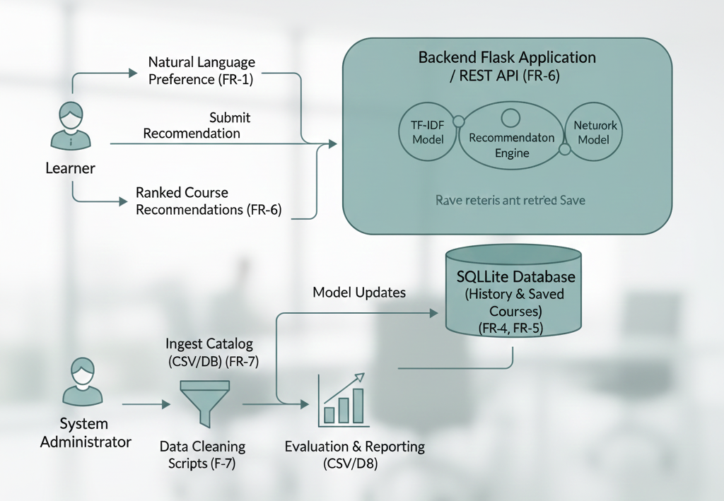

Non-Functional Requirements:
NFR-1 Performance: 95% of recommendation requests must complete within 1.5 seconds for top-10 results after initial model warm-up.
NFR-2 Availability: the service shall restart automatically on failure and present clear messages when models are missing.
NFR-3 Scalability: support catalogs of at least 20,000 courses by swapping model artifacts without code changes.
NFR-4 Security and privacy: validate inputs, log unexpected payloads, and use HTTPS plus least-privilege database access in production.
NFR-5 Usability: maintain responsive Bootstrap layouts with accessible colour contrast and keyboard navigation.
NFR-6 Maintainability: keep modules loosely coupled with configuration-driven behaviour and supply scripts and tests so data preparation is repeatable.
NFR-7 Observability: emit structured logs for recommendation usage, evaluation runs, and critical errors so the team can analyse trends.

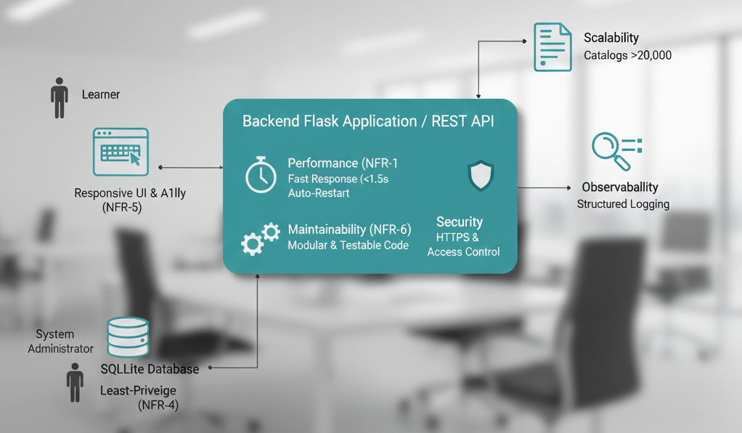

Use Case Diagram(s):

Primary Actors: Learner and System Administrator.
UC-06 Evaluate model quality - Administrator runs evaluation scripts and shares precision/recall metrics with stakeholders.
UC-05 Train and deploy models - Administrator ingests new data, retrains TF-IDF/neural models, and refreshes the backend artifacts.
UC-04 Review and replay history - Learner inspects prior searches and re-runs them from the dashboard.
UC-03 Save or remove promising courses - Learner bookmarks results tied to a SearchSession.
UC-02 Compare TF-IDF versus neural results - Learner views both lists to understand differences.
UC-01 Submit recommendation request - Learner enters a preference and receives ranked courses.

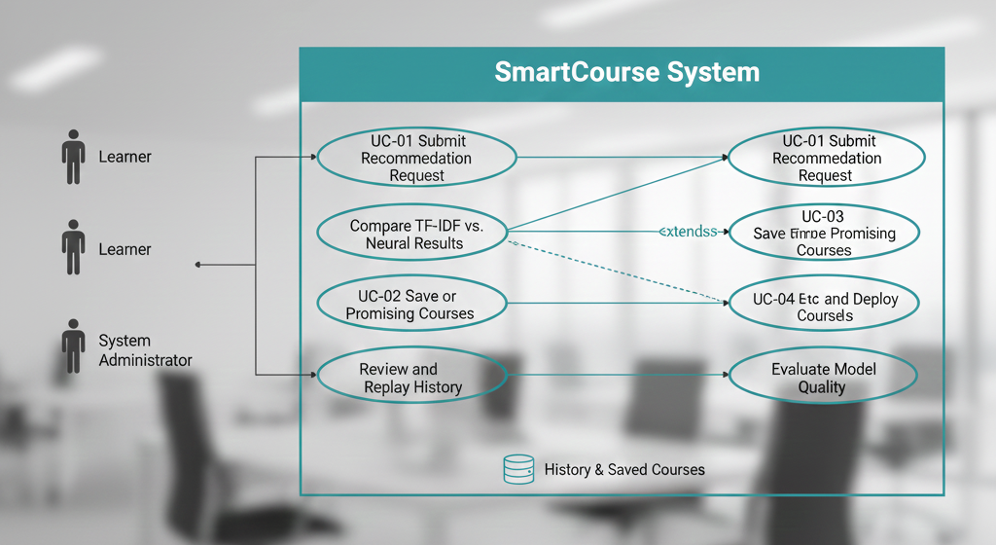

Usage Scenarios
These scenarios illustrate the core interactions between the system's actors (Learner and Administrator) and the SmartCourse recommendation engine.

Scenario 1: Learner-Initiated Recommendation and Comparison
- Actor: Learner
- Description: A learner is seeking new electives based on a specific interest. The system immediately provides recommendations from two competing models, allowing the learner to make an informed choice and save courses for future action.
- Flow: A learner enters the query, "Data storytelling with Python". The system executes the search, comparing results generated by the TF-IDF model and the neural model. The learner reviews the comparative output and saves two highly-rated elective courses to their personal list for follow-up.

Scenario 2: Advisor-Facilitated Review
- Actor: Advisor (Implied actor, typically using the learner's session data)
- Description: An academic advisor uses the persistence features of the system to review a learner's past searches and saved interests to guide their next steps in course enrollment.
- Flow: The advisor accesses the learner's session history to see their past queries. They then open the list of saved recommendations (the two electives from Scenario 1) to understand the learner's preferences and initiate a discussion about the learner's path forward.

Scenario 3: System Administrator Maintenance and Quality Check
- Actor: System Administrator
- Description: The administrator performs routine maintenance to ensure the system's models are trained on the latest course catalog and that performance metrics remain high.
- Flow: The administrator initiates the ingestion of a refreshed course catalog. This is followed by the process to retrain both the TF-IDF and neural models. Finally, the administrator validates the new model performance against stored evaluation metrics and reloads the models into the live Flask service to ensure the new recommendations are active.
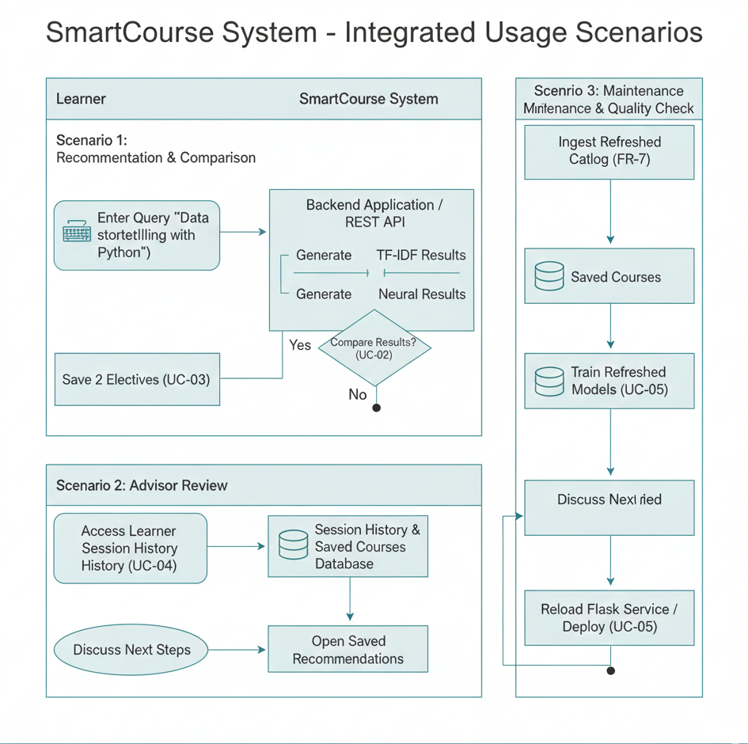

Adopted Methodology
The SmartCourse project will strictly follow the VU Process Model, a structured methodology designed to leverage the best features of both the Waterfall model and the Spiral model. This hybrid approach is particularly effective for projects involving machine learning (AI) components, where early risk assessment and iterative refinement are critical to success, which aligns with the principles explained in the SE2 (CS605) handouts.
The Waterfall approach provides a sequential, document-driven structure for managing the overall project deliverables (SRS, Design, Final Report), while the Spiral approach is embedded within the core development cycles to mitigate technical risks associated with data quality, model training, and performance.
The methodology is divided into four distinct phases:
- Inception (Weeks 1-2): This foundational phase is analogous to the initial planning and analysis stage of the Waterfall model. The primary focus is on establishing a concrete basis for the project.
  - Goal: Confirm project scope and feasibility.
  - Activities: Confirm all stakeholders, finalize success criteria, review and audit initial data sources, and complete the detailed Software Requirements Specification (SRS).
- Elaboration (Weeks 2-4): This phase introduces the risk-assessment loop characteristic of the Spiral model. Technical unknowns are identified and tackled early.
  - Goal: Retire technical risks before major development begins.
  - Activities: Conduct risk spikes and proof-of-concepts focusing on data quality processes, preliminary model training effectiveness, and measuring system latency to ensure performance requirements can be met.
- Construction (Weeks 4-9): This is the primary build phase, where the Waterfall structure guides the sequential implementation of system components.
  - Goal: Iteratively build and integrate core system functionality.
  - Activities: Sequentially deliver the REST API endpoints, develop the user interface (UI), implement database persistence for sessions, and build the dedicated evaluation tooling. This is done in manageable increments to allow for frequent internal review.
- Transition (Weeks 9-12): The final phase focuses on quality assurance and formal project closure, mirroring the deployment and maintenance stages of Waterfall.
  - Goal: Prepare the final system for delivery and demonstration.
  - Activities: Fully integrate all software components, execute comprehensive system and performance tests, finalize polishing of the user experience (UX), update all necessary documentation, and prepare the project materials for the final presentation.
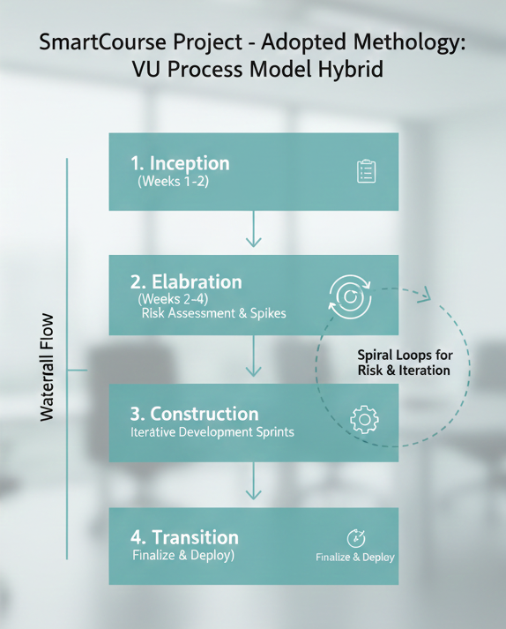

Work Plan
The project spans 175 days, organized into four key phases. Each subsequent phase begins after the completion of the preceding necessary task, ensuring a continuous flow of work.

Phase 1: Requirements & SRS
This phase establishes the foundational documentation for the entire project.
- SRS Document: This task, lasting 30 days, begins on 2025-11-05 and defines all functional and non-functional requirements.

Phase 2: Design & Elaboration
Starting immediately after the SRS is complete, this phase focuses on establishing the architecture and core backend components.
- Design Deliverable: This is a comprehensive task lasting 50 days. It runs concurrently with the technical setup, ensuring architectural guidance throughout the early development process.
- Data Pipeline Setup: This 2-week task involves building the ingestion and cleaning scripts necessary for preparing the course catalog data.
- Flask API Skeleton: Following the pipeline setup, the base framework for the backend REST services is established over 2 weeks, providing the structure for model integration.

Phase 3: Prototype Phase
Building on the foundation from Phase 2, this phase integrates the AI models and implements the core user-facing application features.
- UI Flows & Persistence: The user interface is developed, along with the database logic for sessions and saved courses, taking 3 weeks.
- Model Integration: The TF-IDF and Neural recommendation engines are integrated into the live API, which lasts 2 weeks.
- Evaluation Tooling: The necessary metrics and scripts to measure model quality (precision and recall) are finalized and implemented over 2 weeks.

Phase 4: Final Deliverables
The final phase is dedicated to quality assurance, documentation, and project handover.
- Testing & Performance: A rigorous period of system testing, bug fixing, and performance tuning is conducted over 3 weeks.
- Documentation & Review: All technical and user documentation is finalized and reviewed, lasting 3 weeks.
- Final Presentation: Preparation for the final project demonstration and defense takes 2 weeks.
- Final Submission: The official project closure, requiring 1 day.

